**CNS LAB**

**Name: Samrat Vishwas Jadhav PRN: 2020BTECS00006**

**Assignment 2**

**Aim - Given the plain text, encrypt it using Columnar Encryption Algorithm**

**Columnar Cipher Encryption Algorithm**

In a transposition cipher, the order of the alphabets is re-arranged to obtain the cipher-text.

1. The message is written out in rows of a fixed length, and then read out again column by column, and the columns are chosen in some scrambled order.

1. Width of the rows and the permutation of the columns are usually defined by a keyword.
2. For example, the word HACK is of length 4 (so the rows are of length 4), and the permutation is defined by the alphabetical order of the letters in the keyword. In this case, the order would be “3 1 2 4”.
3. Any spare spaces are filled with nulls or left blank or placed by a character (Example: _).
4. Finally, the message is read off in columns, in the order specified by the keyword 6.

**Code:**

#include <bits/stdc++.h>

using namespace std;

#define ll long long

int main()

{

    string plainText, key;

    cout << "\n Choose an option:\n";

    cout << "  1. Encryption\n";

    cout << "  2. Decryption\n";

    int choice;

    cin >> choice;

    cin.ignore();

    if (choice == 1)

    {

*// Encryption*

        cout << "\n Enter plain text : ";

        getline(cin, plainText);

        cout << "\n Enter key : ";

        getline(cin, key);

*// Removing spaces and converting to lowercase from plaintext*

        string temp = "";

        for (int i = 0; i < plainText.size(); i++)

        {

            if (plainText[i] != ' ')

                temp += tolower(plainText[i]);

        }

        plainText = temp;

*// Removing spaces and converting to lowercase from key*

        string temp2 = "";

        for (int i = 0; i < key.size(); i++)

        {

            if (key[i] != ' ')

                temp2 += tolower(key[i]);

        }

        key = temp2;

*// Encryption*

        map<char, vector<char>> mp;

        int keyCounter = 0;

        for (int i = 0; i < plainText.size(); i++)

        {

            mp[key[keyCounter++]].push_back(plainText[i]);

            if (keyCounter == key.size())

                keyCounter = 0;

        }

*// Print the key letters at the top*

        for (const auto &it : mp)

        {

            cout << it.first << "\t";

        }

        cout << endl;

        cout<<endl;

        int maxColumnSize = 0;

        for (const auto &it : mp)

        {

            maxColumnSize = max(maxColumnSize, static_cast<int>(it.second.size()));

        }

        for (int i = 0; i < maxColumnSize; i++)

        {

            for (const auto &it : mp)

            {

                if (i < it.second.size())

                {

                    cout << it.second[i] << "\t";

                }

                else

                {

                    cout << " \t"; *// Fill with spaces if there's no value in this column*

                }

            }

            cout << endl;

        }

        cout << "\nCipher text is: ";

        string cipherText;

        for (const auto &it : mp)

        {

            for (char c : it.second)

            {

                cipherText += c;

            }

        }

        cout << cipherText << endl;

    }

    else if (choice == 2)

    {

*// Decryption*

        cout << "\n Enter cipher text : ";

        getline(cin, plainText);

        cout << "\n Enter key : ";

        getline(cin, key);

*// Removing spaces and converting to lowercase from key*

        string temp2 = "";

        for (int i = 0; i < key.size(); i++)

        {

            if (key[i] != ' ')

                temp2 += tolower(key[i]);

        }

        key = temp2;

*// Decryption*

        map<int, int> dmp;

        int common = plainText.size() / key.size();

        int extra = plainText.size() % key.size();

        for (int i = 0; i < key.size(); i++)

        {

            if (i < extra)

                dmp[i] = common + 1;

            else

                dmp[i] = common;

        }

        map<int, vector<char>> dmp2;

        int start = 0;

        string sortedKey = key;

        sort(sortedKey.begin(), sortedKey.end());

        for (int i = 0; i < sortedKey.size(); i++)

        {

            for (int j = 0; j < key.size(); j++)

            {

                if (sortedKey[i] == key[j])

                {

                    for (int k = 0; k < dmp[j]; k++)

                    {

                        dmp2[key[j]].push_back(plainText[start++]);

                    }

                }

            }

        }

        string afterDecryption;

        vector<int> counters(key.size(), 0);

        int i = 0;

        while (afterDecryption.size() < plainText.size())

        {

            for (int i = 0; i < key.size(); i++)

            {

                if (counters[i] < dmp[i])

                    afterDecryption += dmp2[key[i]][counters[i]++];

            }

        }

        cout << "\n\n Text after decryption is : " << afterDecryption << endl;

    }

    else

    {

        cout << "\n Invalid choice" << endl;

    }

    return 0;

}

Output:

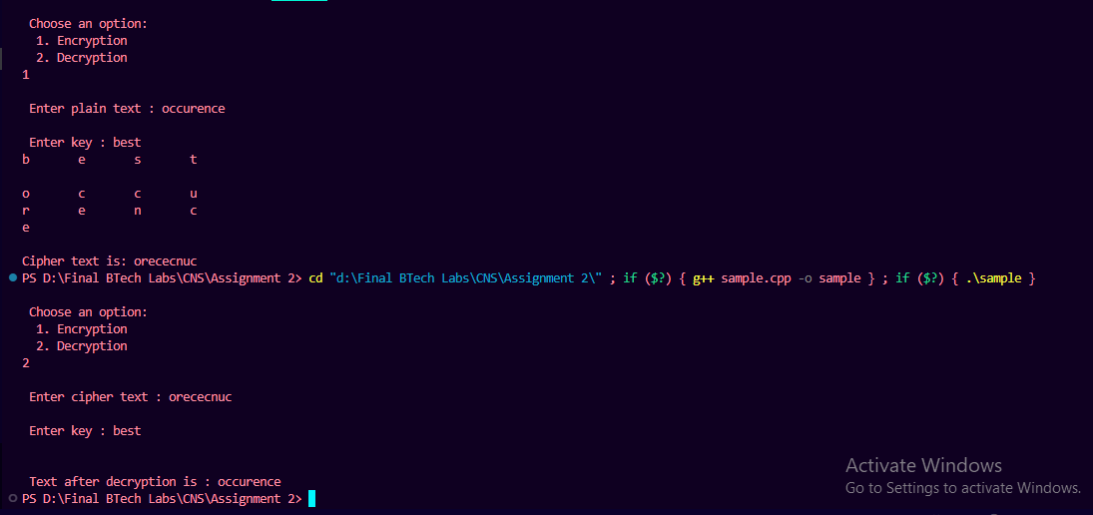

**Rail fence Cipher Encryption Algorithm**

In the rail fence cipher, the plain-text is written downwards and diagonallyon successive rails of an imaginary fence.

When we reach the bottom rail, we traverse upwards moving diagonally, after reachingthe top rail, the direction is changed again. Thus the alphabets of the message are written in a zig-zag manner.

After each alphabet has been written, the individual rows are combined to obtain thecipher-text.

**Code:**

def encryptRailFence(text, key):

    rail = [['*' for i in range(len(text))]

                for j in range(key)]

    dir_down = False

    row, col = 0, 0

    for i in range(len(text)):

        if (row == 0) or (row == key - 1):

            dir_down = not dir_down

        rail[row][col] = text[i]

        col += 1

        if dir_down:

            row += 1

        else:

            row -= 1

    result = []

    for i in range(key):

        for j in range(len(text)):

            print(rail[i][j],end=" ")

            if rail[i][j] != '*':

                result.append(rail[i][j])

        print()

    return("" . join(result))

def decryptRailFence(cipher, key):

    rail = [['\n' for i in range(len(cipher))]

                for j in range(key)]

    dir_down = None

    row, col = 0, 0

    for i in range(len(cipher)):

        if row == 0:

            dir_down = True

        if row == key - 1:

            dir_down = False

        rail[row][col] = '*'

        col += 1

        if dir_down:

            row += 1

        else:

            row -= 1

    index = 0

    for i in range(key):

        for j in range(len(cipher)):

            if ((rail[i][j] == '*') and

            (index < len(cipher))):

                rail[i][j] = cipher[index]

                index += 1

    result = []

    row, col = 0, 0

    for i in range(len(cipher)):

        if row == 0:

            dir_down = True

        if row == key-1:

            dir_down = False

        if (rail[row][col] != '*'):

            result.append(rail[row][col])

            col += 1

        if dir_down:

            row += 1

        else:

            row -= 1

    return("".join(result))

*# Driver code*

if __name__ == "__main__":

    c = int(input("What do you want to perform?\n1. Encryption\n2. Decryption\n"))

    if c==1:

        txt = str(input("Enter the text to be encrypted: "))

        shift = int(input("Enter the Key: "))

        print(f"Ciphertext is:\n{encryptRailFence(txt, shift)}")

    elif c==2:

*# Decryption*

        txt = str(input("Enter the text to be decrypted: "))

        shift = int(input("Enter the Key: "))

        print(f"Ciphertext is:\n{decryptRailFence(txt, shift)}")

Output:

